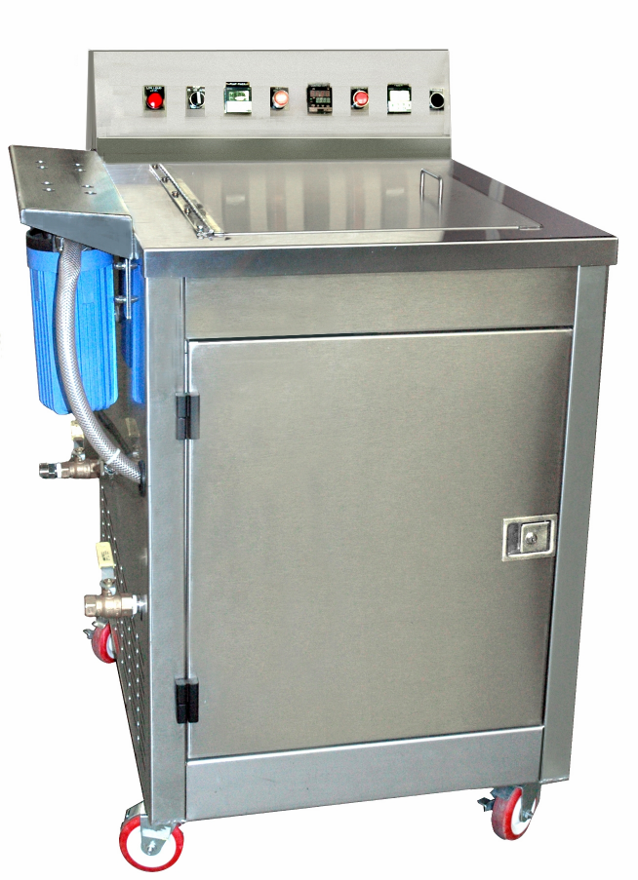

EP1820 ULTRASONIC CLEANING SYSTEM
- Portable / Rugged / Most Advanced Ultrasonic Technology.
- Programmable Digital Control For Temperature-Time / Pump & Dual Filters / Overflow Weir & Surface Sparger / Oil Removal / Cover Converts to Drain Rack.
- Ceramically Enhanced Transducers Provide Effective Ultrasonic Cleaning
- Options: Additional Basket /Auto-Fill
Voltage | 240V / 1 phase
Amps | 37.6
Heat Power in RMS Watts | 4000
Operating Temperature | 130 - 165
Ultrasonic Power in RMS Watts | 2000
Ultrasonic Standard kHz | 40 kHz
Overall Dimensions LR | 26 1/4”
Overall Dimensions FB | 33 1/4”
Overall Dimensions HT | 47 13/16”
Capacity Gallons | 31
Working Tank LR | 18”
Working Tank FB | 20”
Working Tank Liquid Depth | 18”
Basket LR | 15”
Basket FB | 18”
Basket Depth | 18.5”
Wheels | 4 inch Casters
Pump | Included*
Dual Filtration | Included*
Surface Sparger | Included*

