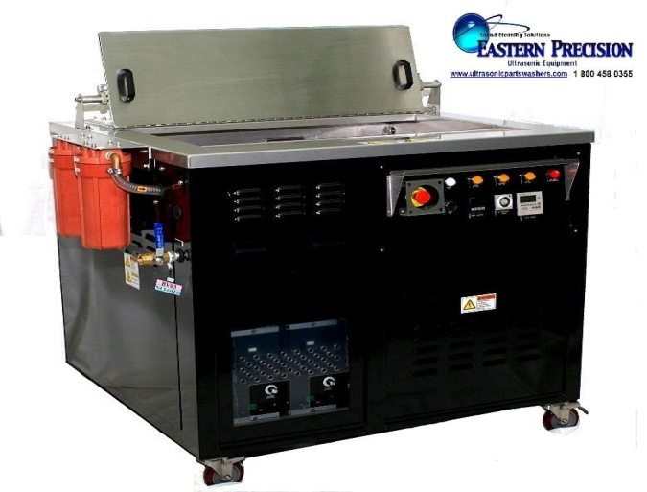


EP3523P

www.ultrasonicpartwashers.com

- Rugged Stainless Steel Tank and Heavy Steel Frame Construction
- Programmable Digital Control: Tank Warm-up, Temperature, Cycle Time
- Eastern Precision Cleaning Systems incorporate the power of Ceramically Enhanced Transducers and adjustable Generators to provide superior ultrasonic cleaning.
- Standard 2 Stage Filtration with optional Oil Skimmer

Environmentally Sound Cleaning

Voltage | 230 Volts, 1 Phase, 60 Hz
Amps | 28 Amps
Heat Power in watts rms | 4000 Watts of Strip Heat
Operating Temperature | 130-180
Ultrasonic Power in watts rms | 2000 Watts RMS of Ultrasonic Power
Ultrasonic Standard kHz | 40 kHz
Overall Dimensions LR | 41.5”
Overall Dimensions FB | 35.25”
Overall Dimensions HT | 36.5”
Capacity Gallons | 42 Gallons Working Solution
Working Tank LR | 35”
Working Tank FB | 23”
Working Tank Liquid Depth | 14.5´Deep (12” Working Depth)
Basket LR | 32”
Basket FB | 20”
Basket Depth | 6”
Wheels | 4” Casters
Pump | 5 GPM Recirculation /Filtration System
Filtration | Wye Strainer / Dual 10” Cartridge Filters
Surface Sparger | Yes

CALL 1 800 458-0355

